**ASSIGNMENT-4**

|  |  |
| --- | --- |
| DATE | 30 October 2022 |
| Team ID | PNT2022TMID49588 |
| Project Name | Project-Personal Expense Tracker |
| Team Member Name | Pavithra M |

**1.Create a Bucket in IBM object storage.**

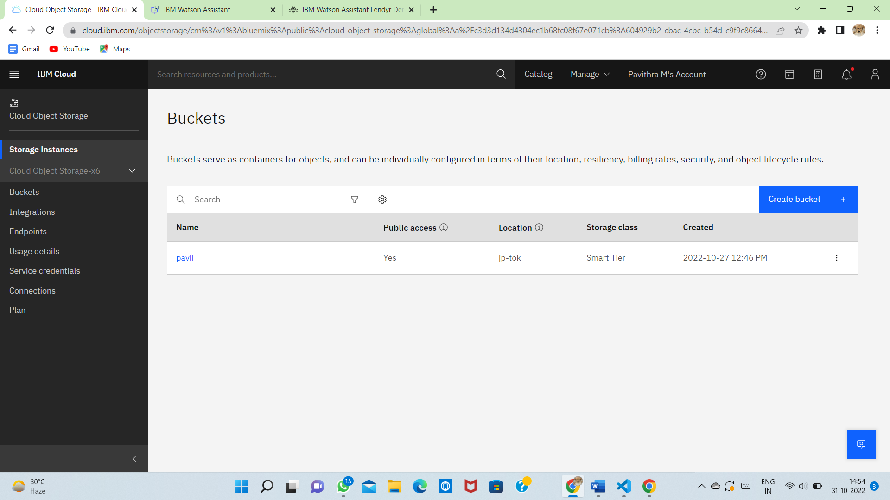

**2.Upload 5 images to ibm object storage and make it public. write html code to displaying all the 5 images.**

**index.html:**

<html>

<head>

<link rel="stylesheet" href="style.css">

</head>

<body>

<div class="row">

<div class="col">

<img src="image1.jpg" height="40"width=50>

<img src="image2.jpg" height="40" width="50">

<img src="image3.jpg" height="40" width="50">

<img src="image4.jpg" height="40" width="50">

<img src="image5.jpg" height="40" width="50">

</div>

</div>

</body>

</html>

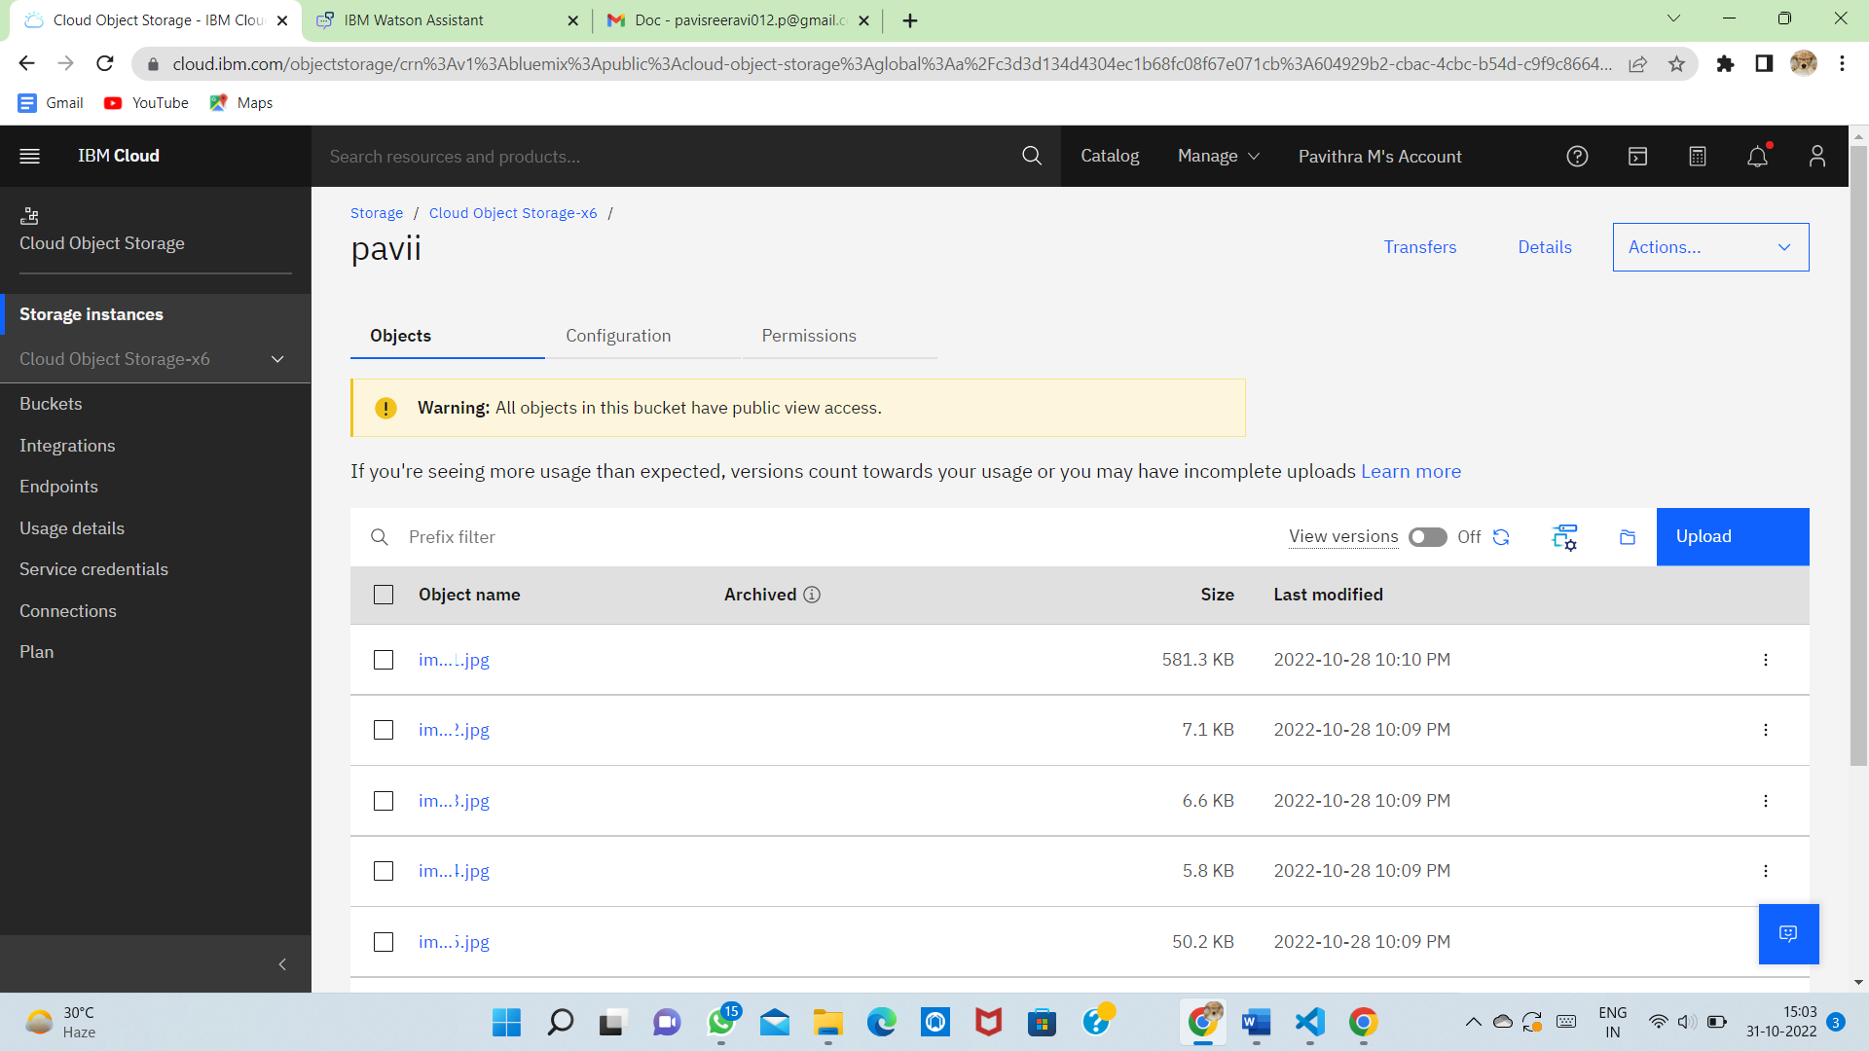

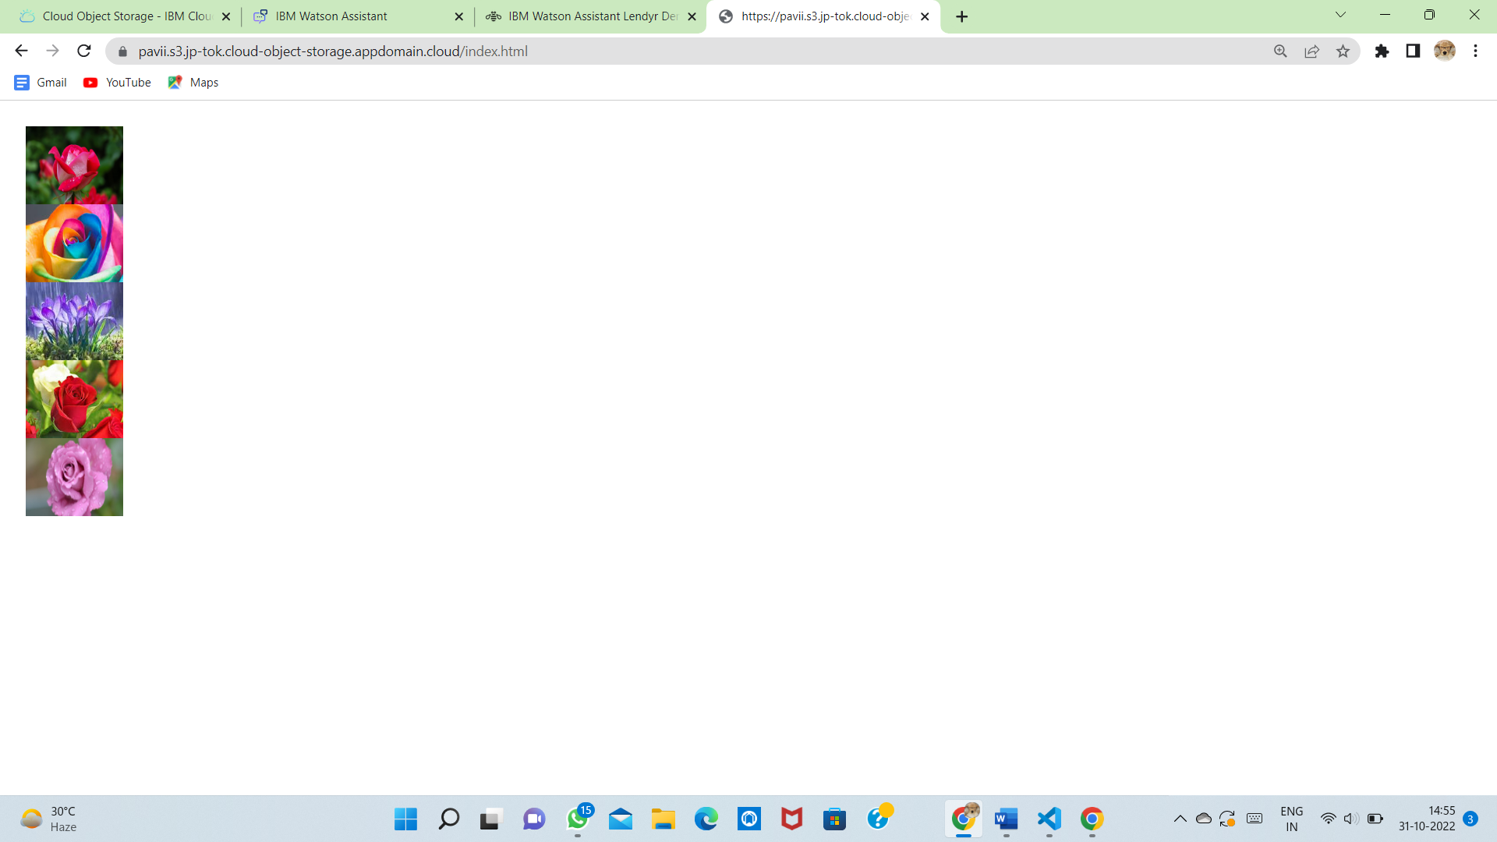

**3.Upload a css page to the object storage and use the same page in your HTML code.**

**style.css**

.row{

float: left;

width: 77%;

padding: 5px;

}

.row::after {

content: "";

clear: both;

display: table;

}

.row {

display: flex;

}

.row {

flex: 55%;

padding: 5px;

}

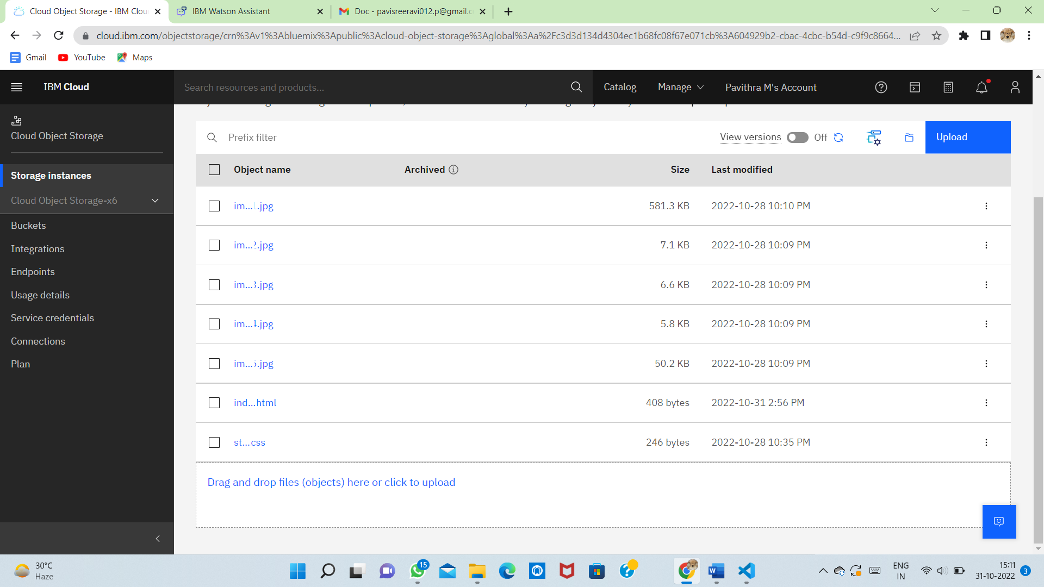

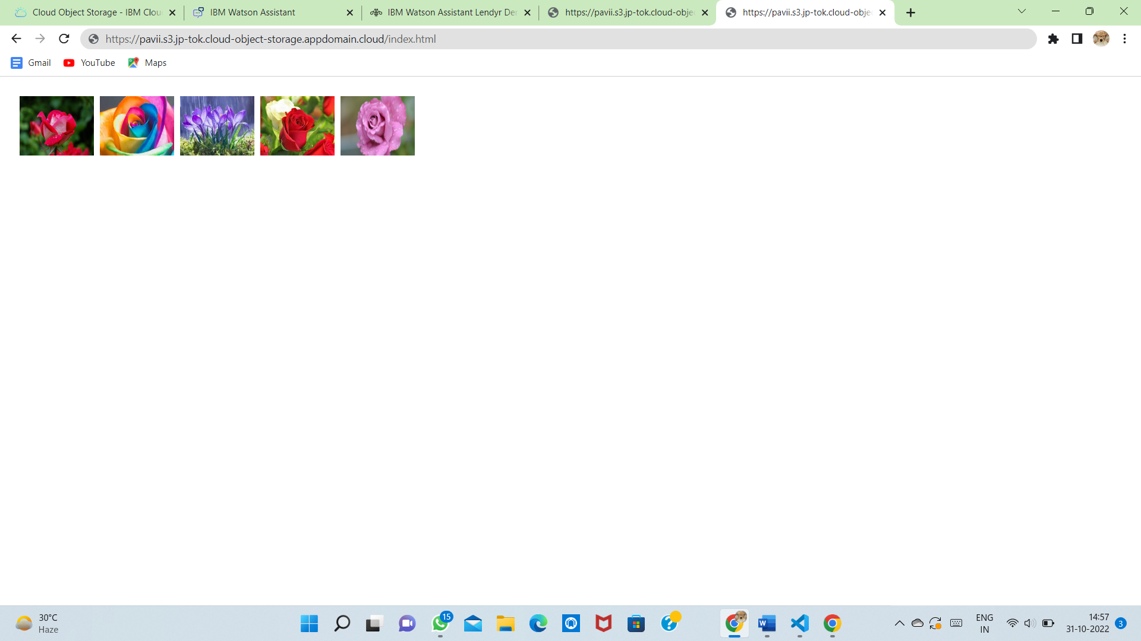

**4.Design a chatbot using IBM Watson assistant for hospitals. Ex: User comes with a query to know the branches for that hospital in your city. Submit the web URL of that chat bot as an assignment.**

**URL:**

<https://web-chat.global.assistant.watson.appdomain.cloud/preview.html?backgroundImageURL=https%3A%2F%2Fus-south.assistant.watson.cloud.ibm.com%2Fpublic%2Fimages%2Fupx-466249f2-1c9f-4fda-a882-8b43f189bf21%3A%3A74217a4d-3539-4667-baab-a27e84dbfc52&integrationID=d0968ac6-4501-4c89-9f43-6c80581e40c3&region=us-south&serviceInstanceID=466249f2-1c9f-4fda-a882-8b43f189bf21>

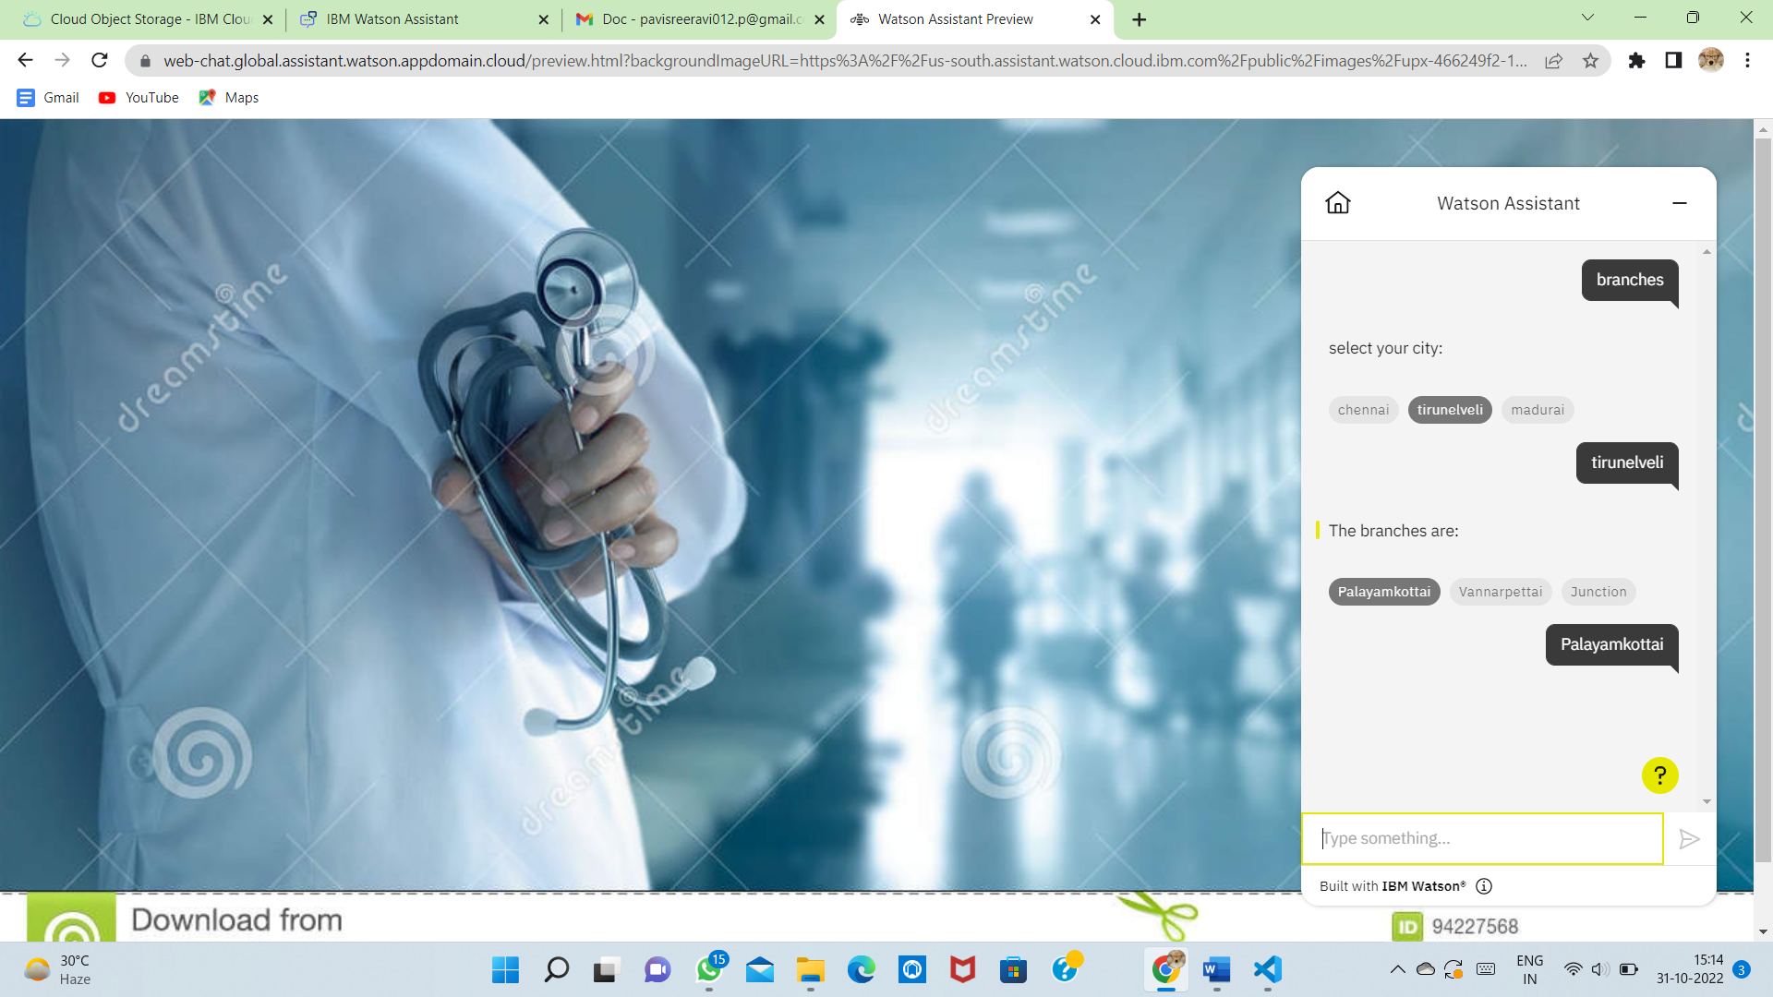

**5.Create Watson assistant service with 10 steps and use 3 conditions in it. Load that script in the HTML page.**

**index.html:**

<html>

<head>

<link rel="stylesheet" href="style.css">

</head>

<body>

<script>

window.watsonAssistantChatOptions = {

integrationID: "053e1c6a-76b6-4029-8491-b8fc0117947d", // The ID of this integration.

region: "us-south", // The region your integration is hosted in.

serviceInstanceID: "466249f2-1c9f-4fda-a882-8b43f189bf21", // The ID of your service instance.

onLoad: function(instance) { instance.render(); }

};

setTimeout(function(){

const t=document.createElement('script');

t.src="https://web-chat.global.assistant.watson.appdomain.cloud/versions/" + (window.watsonAssistantChatOptions.clientVersion || 'latest') + "/WatsonAssistantChatEntry.js";

document.head.appendChild(t);

});

</script>

<div class="row">

<div class="col">

<img src="image1.jpg" height="40"width=50>

<img src="image2.jpg" height="40" width="50">

<img src="image3.jpg" height="40" width="50">

<img src="image4.jpg" height="40" width="50">

<img src="image5.jpg" height="40" width="50">

</div>

</div>

</body>

</html>

